PABNA UNIVERSITY OF SCIENCE AND TECHNOLOGY


Faculty of Engineering & Technology
Department of Information and Communication Engineering

Course name: Signal and Systems Sessional
Course Code: ICE-2204

Submitted By:
Name: Md. Uzzal Mia
Roll: 220605
Reg: 1065452
Session:2021-2022
2nd Year 2nd Semester
Dept. of ICE, PUST

Submitted To:
Dr. Md. Imran Hossain
Associate Professor
Department of Information and Communication Engineering
Pabna University of Science and Technology
Pabna, Bangladesh

Index
Problem Number | Title
01 | Implementation and Analysis of Impulse, Step, and Ramp Functions in Discrete-Time Signals
02 | Basic Operations on Discrete-Time Signals: Addition, Subtraction, Multiplication, Shifting, and Folding
03 | Convolution, Cross-Correlation, and Autocorrelation of Signals
04 | Processing and Heart Rate Detection from PPG Signal
05 | Discrete Fourier Transform (DFT) and Frequency Spectrum Analysis
06 | Noise Reduction in an Audio Signal Using FFT Filtering

Problem Number: 01
Title: Implementation and Analysis of Impulse, Step, and Ramp Functions in Discrete-Time Signals
Objectives:
1. To understand and implement fundamental discrete-time signals Unit Impulse (Dirac Delta) Function, Unit Step Function, Unit Ramp Function
2. To visualize these signals using Python (NumPy & Matplotlib).
3. To analyze their mathematical representations and behaviors in discrete-time domains.
4. To establish a foundation for signal processing applications like convolution and system analysis.
Theory: In Digital Signal Processing (DSP), three fundamental discrete-time signals are commonly used:
1️. Unit Impulse Function (δ[n]):
- Defined as 1 at n = 0, and 0 elsewhere.
- Used to test system responses and as a building block for other signals.
2. Unit Step Function (u[n]):
- Defined as 1 for n ≥ 0, and 0 for n < 0.
- Represents systems that turn on at a certain time.
- Integral (summation) of the impulse function.
3. Unit Ramp Function (r[n]):
- Defined as n for n ≥ 0, and 0 for n < 0.
- Represents a linearly increasing signal over time.
- Integral (summation) of the step function.
These signals are fundamental for analyzing and designing digital systems, helping in convolution, system response analysis, and control system
Source Code:
import numpy as np
import matplotlib.pyplot as plt

# Define functions
def impulse_signal(n):
return np.where(n == 0, 1, 0) # δ[n] = 1 for n=0, else 0

def step_signal(n):
return np.where(n >= 0, 1, 0) # u[n] = 1 for n >= 0, else 0

def ramp_signal(n):
return np.where(n >= 0, n, 0) # r[n] = n for n >= 0, else 0

# Generate signals
n1 = np.arange(-10, 11) # For impulse and step
n2 = np.arange(-5, 6) # For ramp

impulse = impulse_signal(n1)
step = step_signal(n1)
ramp = ramp_signal(n2)

# Create a figure with 3 subplots
plt.figure(figsize=(10, 6))
# Plot Unit Impulse Function
plt.subplot(3, 1, 1)
plt.stem(n1, impulse, use_line_collection=True)
plt.xlabel('n')
plt.ylabel('δ[n]')
plt.title('Unit Impulse Function')
plt.grid(True)

# Plot Unit Step Function
plt.subplot(3, 1, 2)
plt.stem(n1, step, use_line_collection=True)
plt.xlabel('n')
plt.ylabel('u[n]')
plt.title('Unit Step Sequence')
plt.grid(True)

# Plot Unit Ramp Function
plt.subplot(3, 1, 3)
plt.stem(n2, ramp, use_line_collection=True)
plt.xlabel('n')
plt.ylabel('r[n]')
plt.title('Ramp Function')
plt.grid(True)

# Adjust layout and show plot
plt.tight_layout()
plt.show()

Output:
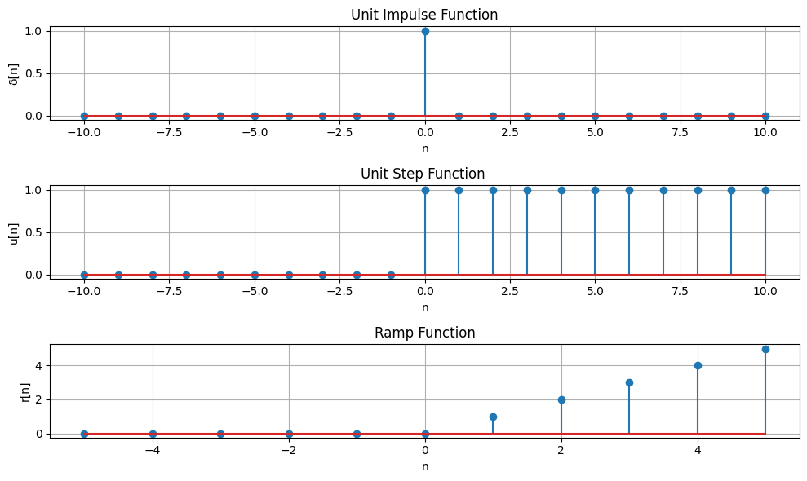
Figure 01: Unit Impulse, Unit Step, and Ramp Function

Problem Number: 02
Title: Basic Operations on Discrete-Time Signals: Addition, Subtraction, Multiplication, Shifting, and Folding
Objectives:
- Addition, Subtraction, Multiplication: These operations modify signal amplitude by combining or altering values at each index.
- Shifting: Moves a signal left (advance) or right (delay), affecting its alignment in time.
- Folding: Flips the signal horizontally, reversing its time indices.
Theory: Discrete-time signals are sequences of values defined at specific time indices. Several fundamental operations can be performed on these signals:
- Addition: Adds two signals element-wise, combining their amplitudes.
- Subtraction: Subtracts one signal from another, showing differences at each index.
- Multiplication: Multiplies two signals element-wise, affecting their amplitudes.
- Shifting: Moves a signal left (advance) or right (delay) in time by a given shift value.
- Folding: Reverses the signal along the time axis, flipping it horizontally.
These operations are essential in signal processing, filtering, and transformation analysis.
Source Code:
import numpy as np
import matplotlib.pyplot as plt

def signal_add(x1, n1, x2, n2):
n_min = min(min(n1), min(n2))
n_max = max(max(n1), max(n2))
n = np.arange(n_min, n_max+1)

y1 = np.zeros(len(n))
y2 = np.zeros(len(n))

y1[np.isin(n, n1)] = x1
y2[np.isin(n, n2)] = x2
return y1+y2, n
def signal_sub(x1, n1, x2, n2):
n_min = min(min(n1), min(n2))
n_max = max(max(n1), max(n2))
n = np.arange(n_min, n_max+1)

y1 = np.zeros(len(n))
y2 = np.zeros(len(n))
y1[np.isin(n, n1)] = x1
y2[np.isin(n, n2)] = x2
return y1-y2, n

def signal_mul(x1, n1, x2, n2):
n_min = min(min(n1), min(n2))
n_max = max(max(n1), max(n2))
n = np.arange(n_min, n_max+1)

y1 = np.zeros(len(n))
y2 = np.zeros(len(n))

y1[np.isin(n, n1)] = x1
y2[np.isin(n, n2)] = x2
return y1*y2, n

# Define two signals
x1 = np.array([1, 2, 3, 4, 5]) # First signal
x2 = np.array([5, 4, 3, 2, 1]) # Second signal

# Define corresponding indices
n1 = np.array([0, 1, 2, 3, 4]) # First signal index
n2 = np.array([1, 2, 3, 4, 5]) # Second signal index

x_add, n_add = signal_add(x1, n1, x2, n2)
x_sub, n_sub = signal_sub(x1, n1, x2, n2)
x_mul, n_mul = signal_mul(x1,n1,x2,n2)
# Create a figure
plt.figure(figsize=(10, 8))

# Plot Original Signal x1
plt.subplot(5, 1, 1)
plt.stem(n1, x1)
plt.title('Original Signal x1')
plt.xlabel('n1')
plt.ylabel('x1(n)')
plt.grid(True)

# Plot Original Signal x2
plt.subplot(5, 1, 2)
plt.stem(n2, x2)
plt.title('Original Signal x2')
plt.xlabel('n')
plt.ylabel('x2(n)')
plt.grid(True)

# Plot Addition
plt.subplot(5, 1, 3)
plt.stem(n_add,x_add)
plt.title('Signal Addition')
plt.xlabel('n')
plt.ylabel('x1(n) + x2(n)')
plt.grid(True)

# Plot Subtraction
plt.subplot(5, 1, 4)
plt.stem(n_sub, x_sub)
plt.title('Signal Subtraction')
plt.xlabel('n')
plt.ylabel('x1(n) - x2(n)')
plt.grid(True)

# Plot Multiplication
plt.subplot(5, 1, 5)
plt.stem(n_mul, x_mul)
plt.title('Signal Multiplication')
plt.xlabel('n')
plt.ylabel('x1(n) * x2(n)')
plt.grid(True)

# Adjust layout
plt.tight_layout()
plt.show()

# ----------------- Signal Shifting and Folding -----------------

import numpy as np
import matplotlib.pyplot as plt

# Function for signal shifting
def signal_shifting(n, shift):
return n + shift # Shift indices by given amount

# Function for signal folding (time reversal)
def signal_folding(x, n):
return np.flip(x), -np.flip(n)

n = np.array([-2, -1, 0, 1, 2])
x = np.array([1, 2, 3, 4, 5]) #

folded_x, folded_n = signal_folding(x, n) # Signal values

# Perform shifting (Right shift by 2)
n_shifted = signal_shifting(n, 2)

# n_folded = -n # Fold indices

# Plot the original signal
plt.figure(figsize=(10, 6))

plt.subplot(3, 1, 1)
plt.stem(n, x1, markerfmt='bo')
plt.title('Original Signal')
plt.xlabel('n')
plt.ylabel('x(n)')
plt.grid(True)

# Plot shifted signal (Right shift by 2)
plt.subplot(3, 1, 2)
plt.stem(n_shifted, x1, markerfmt='ro')
plt.title('Shifted Signal (Right Shift by 2)')
plt.xlabel('n')
plt.ylabel('x(n-2)')
plt.grid(True)

# Plot folded signal (Time Reversal)
plt.subplot(3, 1, 3)
plt.stem(folded_n, folded_x, markerfmt='go')
plt.title('Folded Signal (Time Reversal)')
plt.xlabel('n')
plt.ylabel('x(-n)')
plt.grid(True)

# Show the plots
plt.tight_layout()
plt.show()

Output:
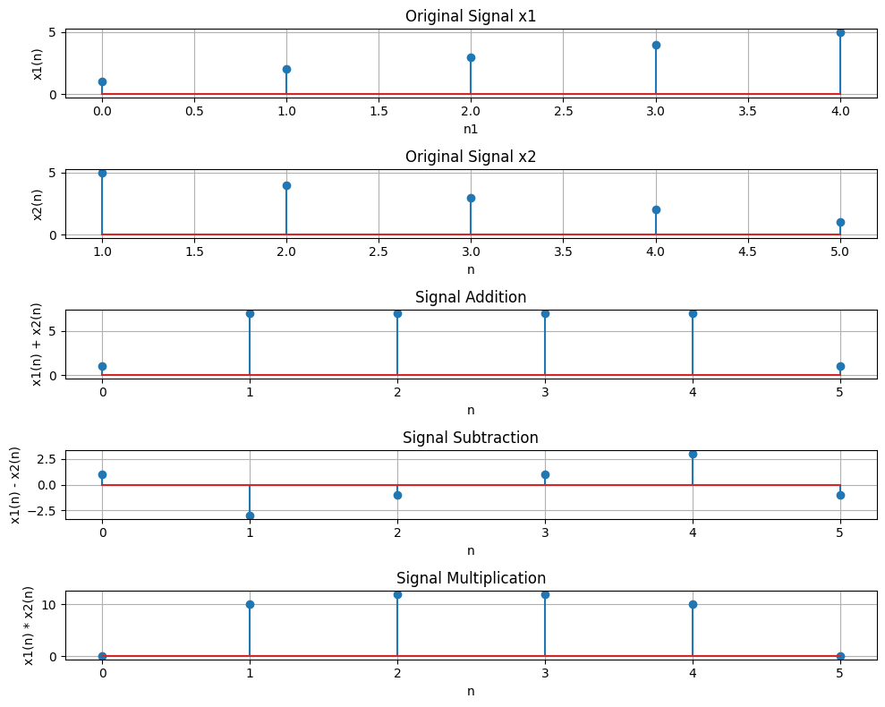
Figure 02: Signal operation addition, subtraction, multiplication

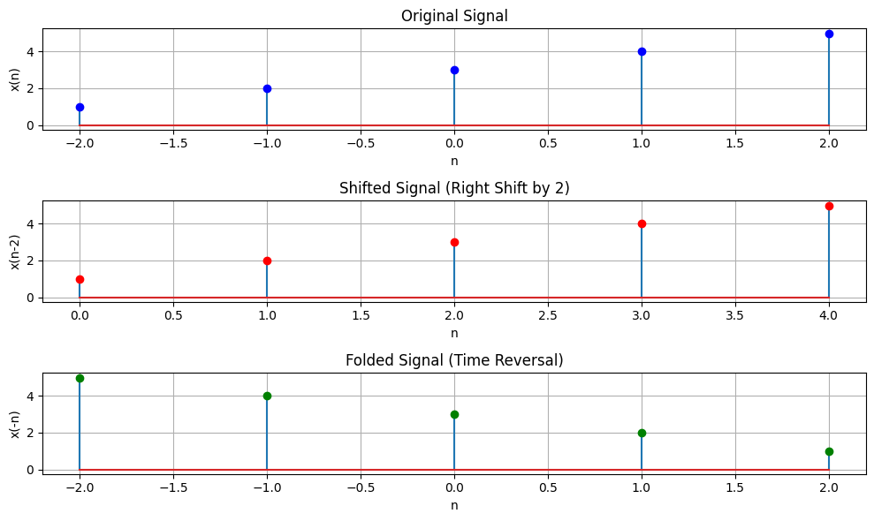

Figure 03: Signal Shifting and folding

Problem Number: 03
Title: Convolution, Cross-Correlation, and Autocorrelation of Signals
Objectives:
- To perform and visualize the convolution of a signal with a kernel.
- To compute and plot the cross-correlation between two signals.
- To compute and plot the autocorrelation of a signal.
- To understand how correlation and convolution are related

Theory:
- Convolution is a mathematical operation that combines two signals to produce a third. It is commonly used in signal processing and image analysis. In discrete time, convolution is computed by flipping the kernel (or filter) and sliding it across the signal.
- Cross-correlation is similar to convolution but without flipping the kernel. It is used to measure the similarity between two signals.
- Autocorrelation is a special case of cross-correlation where the signal is correlated with itself. It is useful for identifying repeating patterns in a signal

Source Code:

import numpy as np
import matplotlib.pyplot as plt
from scipy.signal import correlate, correlation_lags

# Define signal and kernel
signal = np.array([1, 2, 3, 4, 5])
kernel = np.array([1, 0, -1])

# Perform convolution (same as cross-correlation with flipped kernel)
convolved_signal = np.convolve(signal, kernel, mode='full')

# Perform cross-correlation by flipping the kernel
correlated_signal = np.correlate(signal, kernel, mode='full')

# Plot signals
plt.figure(figsize=(10, 4))

# Plot the original signal
plt.subplot(1, 3, 1)
plt.stem(signal)
plt.title('Original Signal')
plt.grid(True)

# Plot the convolved signal
plt.subplot(1, 3, 2)
plt.stem(convolved_signal, linefmt='r', markerfmt='ro')
plt.title('Convolved Signal')
plt.grid(True)

# Plot the correlated signal
plt.subplot(1, 3, 3)
plt.stem(correlated_signal, linefmt='g', markerfmt='go')
plt.title('Correlated Signal')
plt.grid(True)

plt.tight_layout()
plt.show()

# Define autocorrelation function
def compute_autocorrelation(signal):
auto_corr = correlate(signal, signal, mode='full', method='auto')
lags = correlation_lags(len(signal), len(signal), mode='full')
return auto_corr, lags

# Define cross-correlation function
def compute_cross_correlation(signal1, signal2):
cross_corr = correlate(signal1, signal2, mode='full', method='auto')
lags = correlation_lags(len(signal1), len(signal2), mode='full')
return cross_corr, lags

# Sampling frequency and time vector
fs = 1000
t = np.linspace(0, 1, fs)
freq = 5

# Sinusoidal signal
signal1 = np.sin(2 * np.pi * freq * t)

# Autocorrelation of signal1
auto_corr, lags_auto = compute_autocorrelation(signal1)

# Cross-correlation with a shifted version of the signal
signal2 = np.roll(signal1, 100)
cross_corr, lags_cross = compute_cross_correlation(signal1, signal2)

# Cross-correlation with noisy signal
noise = np.random.normal(0, 0.5, fs)
noisy_signal = signal1 + noise
cross_corr_noise, lags_noise = compute_cross_correlation(signal1, noisy_signal)

# Plot all results in one figure
plt.figure(figsize=(12, 8))

# Autocorrelation plot
plt.subplot(3, 1, 1)
plt.plot(lags_auto, auto_corr)
plt.title("Autocorrelation of Sinusoidal Signal")
plt.xlabel("Lag")
plt.ylabel("Autocorrelation")
plt.grid(True)

# Cross-correlation plot (shifted signal)
plt.subplot(3, 1, 2)
plt.plot(lags_cross, cross_corr)
plt.title("Cross-Correlation between Original and Shifted Signal")
plt.xlabel("Lag")
plt.ylabel("Cross-Correlation")
plt.grid(True)

# Cross-correlation with noisy signal
plt.subplot(3, 1, 3)
plt.plot(lags_noise, cross_corr_noise)
plt.title("Cross-Correlation with Noisy Signal")
plt.xlabel("Lag")
plt.ylabel("Cross-Correlation")
plt.grid(True)

# Adjust layout and show the plot
plt.tight_layout()
plt.show()

Output:
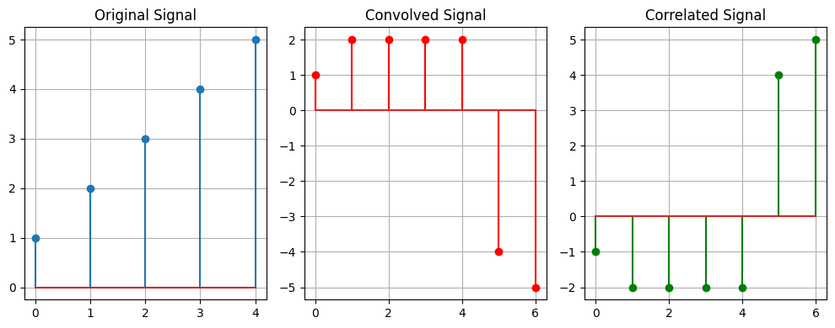
Figure 04: Convolved and Correlated Signal

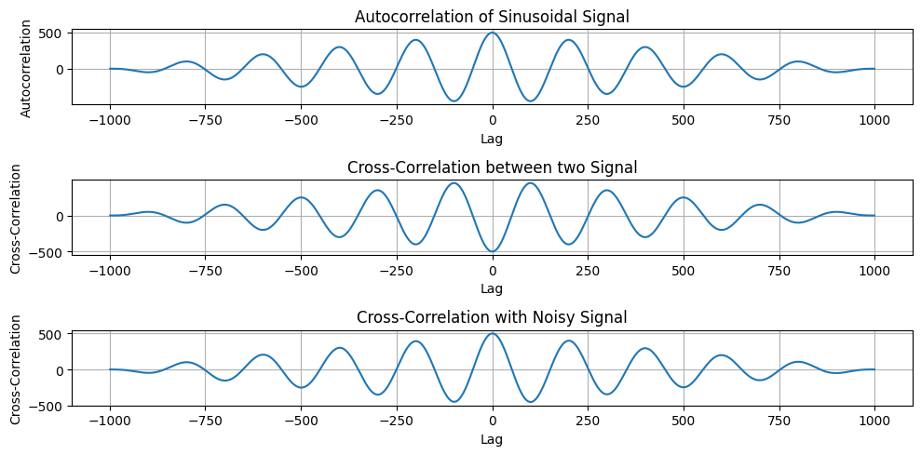
Figure 05: Autocorrelation of Sinusoidal Signal

Problem Number: 04
Title: Processing and Heart Rate Detection from PPG Signal
Objectives:
- To generate and visualize a raw sinusoidal signal, noise signal, and a simulated PPG signal.
- To apply a bandpass filter to the PPG signal to remove unwanted noise.
- To normalize the PPG signal to standardize the amplitude.
- To detect heartbeats using peak detection and compute the heart rate in beats per minute (BPM).
Theory:
- PPG (Photoplethysmogram) is a non-invasive optical measurement used to detect blood volume changes, typically for heart rate monitoring.
- A bandpass filter is used to allow frequencies within a certain range to pass through, removing low-frequency noise (e.g., from baseline wander) and high-frequency noise (e.g., from muscle artifacts).
- Peak detection is used to identify the time points of heartbeats in the filtered PPG signal. The Inter-Beat Interval (IBI) is calculated from the time difference between consecutive peaks, and the heart rate is derived by converting the IBI into beats per minute (BPM).
Source Code:
import numpy as np
import matplotlib.pyplot as plt
from scipy.signal import butter, filtfilt, find_peaks

# Signal parameters
fs = 100
t = np.linspace(0, 10, fs * 10)

# Generate signals
sin_signal = 0.6 * np.sin(2 * np.pi * 1.2 * t)
# Plotting
plt.figure(figsize=(12, 10))
# Subplot 1: Raw Sin Signal
plt.subplot(3, 2, 1)
plt.plot(t, sin_signal)
plt.title("Raw Sin Signal")
plt.xlabel("Time (seconds)")
plt.ylabel("Amplitude")

noise_signal = np.random.normal(0, 0.05, len(t))

# Subplot 2: Raw Noise Signal
plt.subplot(3, 2, 2)
plt.plot(t, noise_signal)
plt.title("Raw Noise Signal")
plt.xlabel("Time (seconds)")
plt.ylabel("Amplitude")

ppg_signal = sin_signal + noise_signal

# Subplot 3: Raw PPG Signal
plt.subplot(3, 2, 3)
plt.plot(t, ppg_signal)
plt.title("Raw PPG Signal")
plt.xlabel("Time (seconds)")
plt.ylabel("Amplitude")

# Bandpass filter function
def bandpass_filter(signal, lowcut, highcut, fs, order=4):
nyquist = 0.5 * fs
low = lowcut / nyquist
high = highcut / nyquist
b, a = butter(order, [low, high], btype='band')
return filtfilt(b, a, signal)

# Filter and normalize PPG signal

filtered_ppg = bandpass_filter(ppg_signal, 0.5, 5, fs)

# Subplot 4: Filtered PPG Signal
plt.subplot(3, 2, 4)
plt.plot(t, filtered_ppg)
plt.title("Filtered PPG Signal")
plt.xlabel("Time (seconds)")
plt.ylabel("Amplitude")

normalized_ppg = (filtered_ppg - np.min(filtered_ppg)) / (np.max(filtered_ppg) - np.min(filtered_ppg))

# Subplot 5: Normalized PPG Signal
plt.subplot(3, 2, 5)
plt.plot(t, normalized_ppg)
plt.title("Normalized PPG Signal")
plt.xlabel("Time (seconds)")
plt.ylabel("Normalized Amplitude")

# Detect peaks in the PPG signal
peaks, _ = find_peaks(normalized_ppg, distance=fs * 0.6)
ibi = np.diff(peaks) / fs # Inter-beat interval in seconds
heart_rate = 60 / ibi # Heart rate in BPM

# Subplot 6: PPG Signal with Detected Peaks
plt.subplot(3, 2, 6)
plt.plot(t, normalized_ppg)
plt.plot(t[peaks], normalized_ppg[peaks], "x", label="Peaks")
plt.title("PPG Signal with Detected Peaks (Heartbeats)")
plt.xlabel("Time (seconds)")
plt.ylabel("Normalized Amplitude")
plt.legend()

plt.tight_layout()
plt.show()

# Print Heart Rate
print("Heart Rate: ", np.mean(heart_rate), " BPM")

Output:
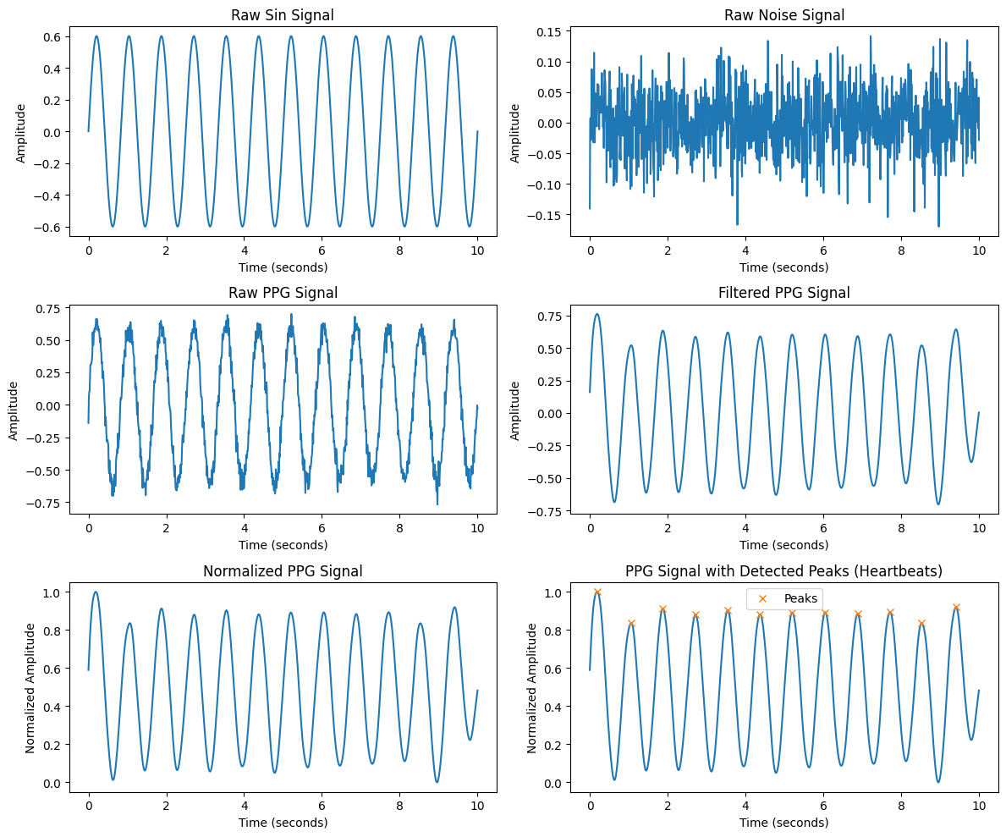
Figure 06: PPG Signal Processing

Problem Number: 05
Title: Discrete Fourier Transform (DFT) and Frequency Spectrum Analysis
Objectives:
- Understand the Discrete Fourier Transform (DFT): Learn how DFT converts a time-domain signal into its frequency-domain representation.
- Implement DFT in Python: Compute the DFT manually using nested loops to understand it’s working.
- Analyze Frequency Components: Decompose a signal into its constituent frequencies and observe their magnitudes.
- Visualize the Spectrum: Plot the frequency spectrum to identify dominant frequency components in a given signal.
- Compare with FFT: Recognize how manual DFT implementation relates to the efficient Fast Fourier Transform (FFT) algorithm.
Theory:
The Discrete Fourier Transform (DFT) is a fundamental mathematical tool used in signal processing to analyze the frequency components of a discrete-time signal. It converts a time-domain signal into its frequency-domain representation.

$$X\left[k\right]=\sum_{n=0}^{N-1}{x\left[n\right]}⋅e^{-j2πkn/N}, k=0,1,2,…,N$$

Implementation in Python:
The provided Python code computes the DFT of a sampled signal containing two sine waves at 50 Hz and 120 Hz. It:
- Generates a time-domain signal composed of sine waves at different frequencies.
- Computes the DFT manually using nested loops.
- Uses np.fft.fftfreq to obtain corresponding frequency bins.
- Plots the single-sided magnitude spectrum to visualize the frequency components present in the signal.

Source Code:
import numpy as np
import matplotlib.pyplot as plt

# Compute the Discrete Fourier Transform (DFT)
def DFT(x):
N = len(x)
X = np.zeros(N, dtype=complex) # Output array (complex numbers)

for k in range(N): # Loop over frequency bins
for n in range(N): # Loop over time samples
X[k] += x[n] * np.exp(-2j * np.pi * k * n / N)

return X

# Create a sample signal (two sine waves)
Fs = 1000 # Sampling rate
T = 1 / Fs # Sampling interval
t = np.linspace(0, 1, Fs, endpoint=False) # 1 second duration

# Signal: Combination of 50 Hz and 120 Hz sine waves
f1, f2 = 50, 120
signal = np.sin(2 * np.pi * f1 * t) + 0.5 * np.sin(2 * np.pi * f2 * t)

# Compute DFT
dft_output = DFT(signal)

# Compute frequency bins
freqs = np.fft.fftfreq(len(dft_output), T)

# Plot magnitude spectrum (single-sided)
plt.figure(figsize=(10, 5))
plt.plot(freqs[:Fs//2], np.abs(dft_output[:Fs//2])) # Single-sided spectrum
plt.title("DFT Frequency Spectrum")
plt.xlabel("Frequency (Hz)")
plt.ylabel("Magnitude")
plt.grid()
plt.show()
import numpy as np
import matplotlib.pyplot as plt
from scipy.fft import fft, ifft, fftfreq

Output:
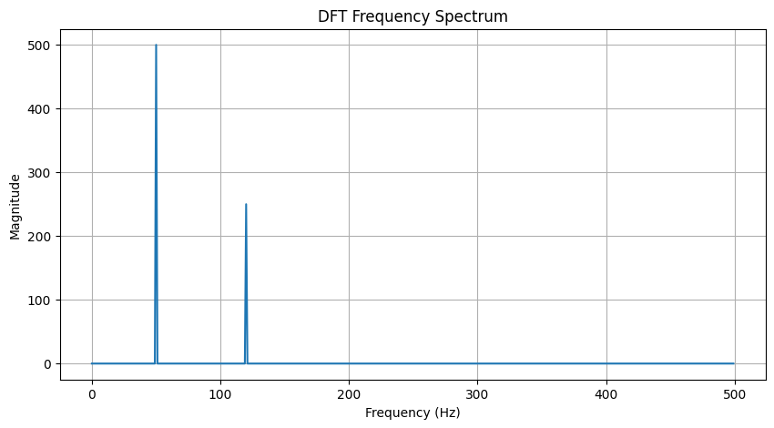
Figure 07: DFT Frequency Spectrum

Problem Number: 06
Title: Noise Reduction in an Audio Signal Using FFT Filtering
Objectives:
- Generate an Audio Signal: Create a pure sine wave signal (440 Hz, "A4" note).
- Introduce Noise: Add random noise to simulate real-world interference.
- Apply Fourier Transform: Use the Fast Fourier Transform (FFT) to analyze frequency components.
- Filter High Frequencies: Remove noise by filtering out frequencies above 500 Hz.
- Reconstruct the Signal: Use the Inverse FFT (IFFT) to obtain a cleaner signal.
- Visualize Results: Compare the original, noisy, and filtered signals using plots

Theory: Fast Fourier Transform (FFT) is a mathematical algorithm used to convert a signal from the time domain to the frequency domain. The Inverse FFT (IFFT) allows us to reconstruct the time-domain signal after filtering.
A sine wave is a fundamental periodic signal that can be represented as:
x(t)=Asin(2πft)
where A is the amplitude, fff is the frequency, and ttt is time.
Steps in Noise Reduction Using FFT:
- Transform to Frequency Domain: The noisy signal is converted using FFT.
- Apply Filtering: Frequencies above 500 Hz are set to zero, preserving the fundamental 440 Hz component.
- Reconstruct the Signal: The filtered signal is transformed back using IFFT, reducing noise.
This method is commonly used in signal processing to enhance audio quality and remove unwanted noise.

Source Code:
# Generate a sample audio signal
Fs = 1000 # Sampling rate (1000 Hz)
T = 1 / Fs # Sampling interval
t = np.linspace(0, 1, Fs, endpoint=False) # 1 second time vector

# Generate a pure sine wave (440 Hz, like an "A4" musical note)
freq_signal = 440
pure_signal = np.sin(2 * np.pi * freq_signal * t)

# Add random noise
noise = np.random.normal(0, 0.5, pure_signal.shape)
noisy_signal = pure_signal + noise

# Apply FFT
fft_signal = fft(noisy_signal)
freqs = fftfreq(len(fft_signal), T) # Frequency bins

# Filter: Remove frequencies higher than 500 Hz
fft_filtered = fft_signal.copy()
fft_filtered[np.abs(freqs) > 500] = 0 # Zero out high frequencies (noise)

# Apply Inverse FFT to get the cleaned signal
cleaned_signal = ifft(fft_filtered).real

# Plot the results
plt.figure(figsize=(12, 6))

plt.subplot(3, 1, 1)
plt.plot(t, pure_signal, label="Original Signal (440 Hz)")
plt.legend()
plt.title("Original Pure Signal")

plt.subplot(3, 1, 2)
plt.plot(t, noisy_signal, label="Noisy Signal", color="red")
plt.legend()
plt.title("Noisy Signal")

plt.subplot(3, 1, 3)
plt.plot(t, cleaned_signal, label="Cleaned Signal (After FFT Filtering)", color="green")
plt.legend()
plt.title("Filtered Signal (Noise Removed)")

plt.tight_layout()
plt.show()

Output:
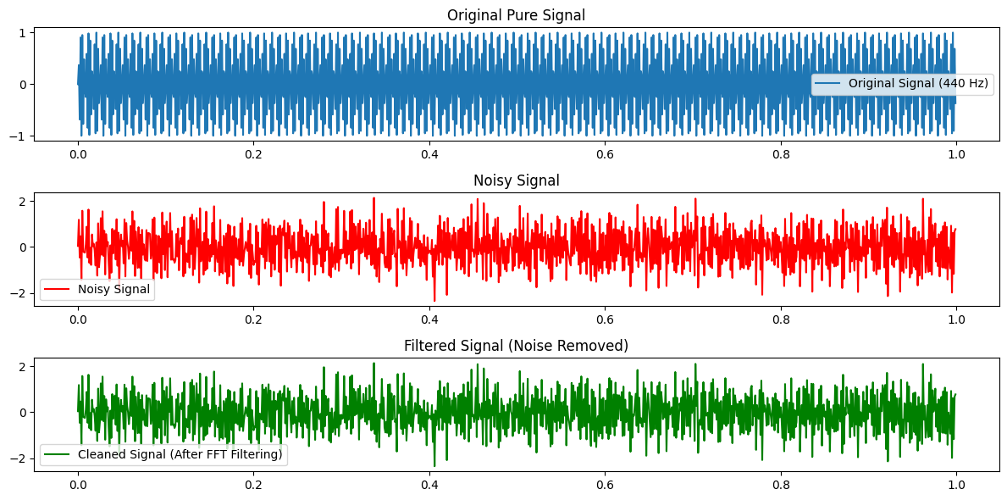
Figure 08: Comparison of Original, Noisy, and Filtered Signals (FFT-Based Noise Removal)

